EVDE YAŞAM İPUÇLARI
Son zamanlarda etrafımızda ücretsiz konserlerden online müze turlarına, kurumların açtığı youtube kanallarından çeşitli canlı yayınlara çok fazla platform ve bilgi mevcut. İlk gördüğümüzde heyecanla mutlaka bakarım dediğimiz kanal veya web sitelerini iki gün geçmeden unutuyoruz. Bu kadar bilgi akışı hepimiz için çok fazla. Hadi itiraf edelim, aslında bazıları her zaman ücretsiz olan, daha önce varlığından bile haberdar olmadığımız site ve kanalları bu dönem sayesinde keşfediyoruz. Ne güzel!
Kendimize yatırım yapmak istersek internet bir derya deniz. Bu denizde kaybolmamak için sizlere birçok değerli kaynaktan faydalanarak 10 sayfalık bir dijital rehber hazırladım. Elbette ki eksikler kalmıştır, internet sonsuz bir kaynak. Rehberde farklı kategoriler altında, evden izlenebilecek konser, opera, bale ve etkinliklere; film ve kitap önerilerine; katılabileceğimiz müze turları ve online sergilere; uzaktan gezilebilecek tarihi mekanlara; eğitim platformları ve binlerce ücretsiz derse; portallara ve çeşitli youtube kanallarına; evde spor ve yemek önerilerine ulaşabilirsiniz. Rehberin en sonunda da faydalandığım kaynakları bulabilirsiniz.
Elbette internetteki kaynaklar dışında da evde yapılabilecek çok fazla şey var. Beraber oynayabileceğimiz aile ve kutu oyunları, kendimizin üretebileceği sanatsal/bilimsel proje ve fikirler gibi. Yaratıcılık size kalmış. Rehberden faydalanmanız dileğiyle,

Gökçe Bilici, Uzm. Psk.

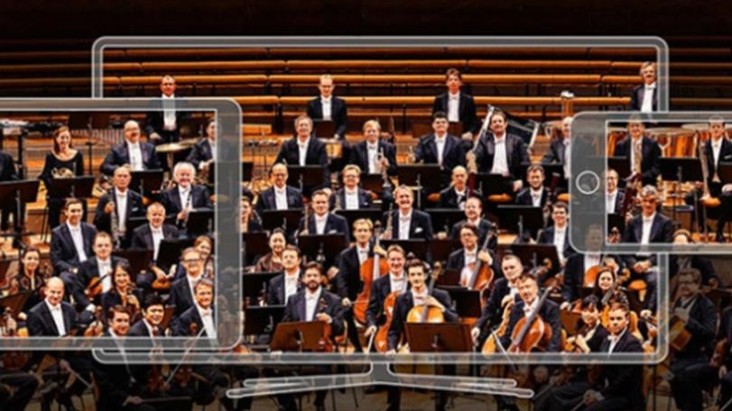

KONSER & OPERA & BALE & ETKİNLİKLER
Social Distancing Festival | https://www.socialdistancingfestival.com/
Kumbaracı 50 – Kapı Açık Kalmış | https://www.youtube.com/user/AltidanSonraTiyatr o
Viyana Devlet Operası Konserleri | https://www.staatsoperlive.com/
Berlin Filarmoni Orkestrası Konserleri | https://www.digitalconcerthall.com/en/home
Metropolitan Operası Konserleri | https://www.metopera.org/
Budapest Festival Orchestra | https://bfz.hu/en/media/quarantine-soirees/
Live Music Archive | https://archive.org/details/etree
Vancouver Symphony / BeethovenFest Son Konser | https://www.vancouversymphony.ca/vsolivestream/
Vancouver Symphony / BeethovenFest Son Konser | https://www.facebook.com/VSOrchestra/videos/27 98750073578921/
Royal Opera House: London / Tüm gösteriler | https://www.youtube.com/user/royaloperahouse
Beckett by Brook | https://vimeo.com/398851333?fbclid=IwAR3PJTK Jny7S-  jnBeVF8mc7FS5qgBmW03eeN9k8paoOW0v5Hc  XzrfR0rpT8
48. İstanbul Müzik Festivali | https://open.spotify.com/playlist/5hINb0obnaOZK CAWzyiBLK
Canlı Klasik Müzik Konserleri | https://www.bostonglobe.com/2020/03/13/arts/allclassical-music-you-can-livestream-free/
Çeşitli Konserler | https://www.nytimes.com/2020/03/13/arts/music/c oronavirus-pandemic-music-streaming.html

FİLM ÖNERİLERİ
Open Culture - Ücretsiz Filmler | http://www.openculture.com/freemoviesonline
Çağdaş Gösteri Sanatları Filmleri Arşivi | https://www.ontheboards.tv/?fbclid=IwAR211qloU pYXuGbA_rZ618LGfcsq3JO9ni7GyNQ3mqxcHh OUPI9HKg8gxdc
IDFA The International Documentary Film Festival Amsterdam – 300 Film | https://www.idfa.nl/en/info/watch-films-online
En iyi 100 IMDB Filmi | https://www.imdb.com/list/ls055592025/
Yolculuk Terapisi’nden Film Önerileri | http://www.yolculukterapisi.com/filmlistesi/

KİTAP ÖNERİLERİ
Open Culture – 800 Ücretsiz E-kitap | http://www.openculture.com/free_ebooks
Open Culture – 700 Ücretsiz Sesli Kitap | http://www.openculture.com/freeaudiobooks
Open Culture – 200 Ücretsiz Ders Kitabı | http://www.openculture.com/free_textbooks
Can Yayınları - Trendeki Yabancı Uygulaması | https://canyayinlari.com/yazidetay/10532/evindekalanlar-icin-kalpten-kucuk-bir-hediye/
JSTOR – Ücretsiz e-kitap ve makaleler | https://www.jstor.org/?refreqid=search%3A72980 6f00c3f821a79211d77562e4d31
Onedio Kitap Önerileri | https://onedio.com/haber/olmeden-onceokumaniz-gereken-bir-doneme-damgasinivurmus-100-kitap-888952
Kitap Önerileri | https://betulvargun.tumblr.com/post/17418913910  0/kitap-%C3%B6nerileri-dostoyevskiyeralt%C4%B1ndan-notlar
Storytel – İlk 30 Gün Ücretsiz | https://www.storytel.com/tr/tr/
Audioteka - Türkçe Sesli Kitaplar | https://audioteka.com/tr/

MÜZELER
Metropolitan Museum - New York | https://www.metmuseum.org/art/collection/
Louvre - Paris | https://www.louvre.fr/en/visites-en-ligne
Pinacoteca di Brera - Milano | https://pinacotecabrera.org/
Galleria degli Uffizi - Floransa | https://www.uffizi.it/mostre-virtuali
Museo Archeologico - Atina | https://www.namuseum.gr/en/collections/
Prado - Madrid | https://www.museodelprado.es/en/thecollection/art-works
British Museum - Londra | https://www.britishmuseum.org/collection
Musei Vaticani - Roma | http://www.museivaticani.va/content/museivaticani /it/collezioni/catalogo-online.html
National Gallery of art - Washington | https://www.nga.gov/index.html
Canadian Museum of History | https://www.historymuseum.ca/collections/
South West Collections | https://swcollectionsexplorer.org.uk/
Brooklands Museum | https://www.brooklandsmuseum.com/explore/ourcollection
Open Access at the Met | https://www.metmuseum.org/about-themet/policies-and-documents/open-access
New York Archaelogical Repository | http://archaeology.cityofnewyork.us/
Cooper Hewitt | https://collection.cooperhewitt.org/
Cleveland Museum of Art | https://www.clevelandart.org/art/collection/search

Albright-Knox | https://www.albrightknox.org/search-collection
Corning Museum of Glass | https://www.cmog.org/collection/search
The Henry Ford | https://www.thehenryford.org/collections-andresearch/digital-collections/
Akron Art Museum | https://akronartmuseum.org/collection/
Oakland Museum of California | http://collections.museumca.org/
Guggenheim - New York | https://artsandculture.google.com/streetview/solo  mon-r-guggenheim-museum-interiorstreetview/jAHfbv3JGM2KaQ
Musee d'Orsay- Paris | https://artsandculture.google.com/partner/museedorsay-paris?hl=en
Musée d’Orsay - Paris | https://artsandculture.google.com/streetview/mus  %C3%A9e-d%E2%80%99orsayparis/KQEnDge3UJkVmw?sv_h=272&sv_p=0&sv _pid=FjndSjvl55w81vbNYu5DfA&sv_lid=6004477 680878644429&sv_lng=2.327089926444344&sv_ lat=48.85968476784497&sv_z=1.0000000000000  002
Pergamon | https://artsandculture.google.com/entity/pergamon /m05tcm?hl=en
Rijksmuseum - Amsterdam | https://artsandculture.google.com/streetview/rijks  museum/iwH5aYGoPwSf7g?hl=en&sv_lng=4.885 283712508563&sv_lat=52.35984312584405&sv_ h=311.1699875145569&sv_p=-  5.924133903625474&sv_pid=fOVcUXQW2wpRf3  3iUmxEfg&sv_z=1.0000000000000004
Van Gogh Museum- Amsterdam | https://artsandculture.google.com/partner/vangogh-museum?hl=en
The J. Paul Getty Museum | https://artsandculture.google.com/partner/the-jpaul-getty-museum?hl=en
Arkas Sanat Merkezi | http://www.arkassanatmerkezi.com/article.aspx?p ageID=18
İstanbul Modern | https://www.istanbulmodern.org/tr
15. İstanbul Bienali | https://artsandculture.google.com/partner/15thistanbul-biennial
Pergamonmuseum - Berlin | https://artsandculture.google.com/streetview/perg amonmuseum-staatliche-museen-zu-  berlin/0QEALap3qf0s1g?sv_lng=13.39664970000 0012&sv_lat=52.5206272&sv_h=57.0166379158  6235&sv_p=4.154513706404231&sv_pid=rTzlWY  -  F4hP2acX_uQhcFA&sv_z=0.5381992096877048  &sv_lid=9073433258708332870
Fuji Art Museum - Tokyo | https://artsandculture.google.com/streetview/tokyo  -fuji-art-museum/SQF48doDyU5Jg?sv_lng=139.3298309108167&sv_lat=35.68687 206332551&sv_h=21&sv_p=0&sv_pid=mb3V4nE  T_bV6TtOB1J59uA&sv_z=1.0000000000000002
Museu de Arte - São Paulo | https://artsandculture.google.com/streetview/mas p-museu-de-arte-de-s%C3%A3o-paulo-assischateaubriand/YgHyUAyv_g4cvg?sv_lng=46.65608128276551&sv_lat=-  23.56142676429897&sv_h=0&sv_p=0&sv_pid=7nij_UbSHfotdh5dcIn2g&sv_lid=15029704351325 382912&sv_z=1
Dr. Bhau Daji Lad Museum - Mumbai | https://artsandculture.google.com/streetview/iQHT
UIXluxuoGQ?sv_h=24&sv_p=0&sv_pid=27OFUb
OPaxcUxXRJudclJw&sv_lid=1803379009100677 7634&sv_lng=72.83476251914539&sv_lat=18.97
903341215466&sv_z=1.0000000000000002
Pitt Rivers Museum | https://my.matterport.com/show/?m=ns3yCKpUzS q&help=1
Dali Theatre museum | https://www.salvador-dali.org/en/museums/dalitheatre-museum-in-figueres/visita-virtual/
The Vatican | http://www.museivaticani.va/content/museivaticani /en/collezioni/musei/tour-virtuali-elenco.html
Hallwyl Museum | https://www.youtube.com/watch?v=iLVGWOtw2P M&feature=youtu.be
Byzantine and Christian Virtual Museum | http://www.ebyzantinemuseum.gr/?i=bxm.en.virtu al-tour
The Hermitage | https://www.youtube.com/watch?v=49YeFsx1rIw& feature=youtu.be
Westminster Abbey | https://www.westminsterabbey.org/learning/virtual-tours
The Science Museum | https://www.sciencemuseum.org.uk/what-wason/shipping#virtual-tour
National Archaeological Museum | https://www.manvirtual.es/
The Fric | https://www.thefrickpittsburgh.org/virtual
Cranbrook Art Museum | https://cranbrookartmuseum.org/3d-virtualexhibition-tours/
Yellowstone National Park | https://www.nps.gov/yell/learn/photosmultimedia/v irtualtours.htm?
Yosemite National Park | https://www.virtualyosemite.org/

SERGİLER
Radical Geometries - Boston | https://artsandculture.google.com/search?q=geor ge%20peabody
Arkas Sanat Merkezi | http://www.arkassanatmerkezi.com/article.aspx?p ageID=11
Virtual Migration Museum | https://virtuelles-migrationsmuseum.org/en/aboutthe-museum/
National Museum of Canada | https://www.historymuseum.ca/?fbclid=IwAR2jEIF fIoXC7IQ-KOICMBU-  LHtR1tsPiK62yiScLJ_AabUpfTesjbdT5LY#onlineexhibitions
12 Banksy Murals | https://artsandculture.google.com/theme/12banksy-murals-you-can-see-on-streetview/NwLyuEgokJgAKQ
Yayoi Kusama: Infinity Mirrors | https://www.youtube.com/watch?v=8VwJMw_fLvI
İstanbul Modern - Sanatçı ve Zaman | https://www.istanbulmodern.org/tr/sergiler/sanatcive-zamani-sanal-tur_2249.html
İstanbu Modern - Yüzyıllık Aşk | https://www.istanbulmodern.org/tr/sergiler/gecmissergiler/yuzyillik-ask_1436.html
Evin Art Gallery | http://www.evin-art.com/
Art x-ist | https://www.artxist.com/
British Council - Duvarları Olmayan Müze | http://exhibitions.britishcouncil.org/main-en.html
Art Basel | https://www.artbasel.com/viewing-rooms
Master Art Vr | https://www.masterartvr.com/Tours
Royal Acemy of Arts - London | https://linktr.ee/royalacademyarts

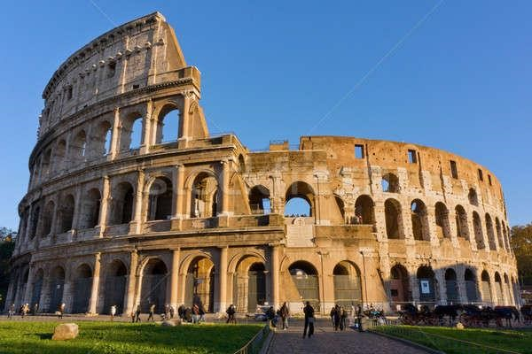

TARİHİ MEKANLAR
Pompeii | https://artsandculture.google.com/streetview/pom peii/DQHczKZUoHnwiQ?sv_lng=14.48418191683 751&sv_lat=40.75066521659861&sv_h=56.1492 7890003092&sv_p=8.471776713440619&sv_pid  =Wd1TNLs3B0y1eYw3fqsPQQ&sv_z=1.0000000 000000002
Versailles Sarayı | https://artsandculture.google.com/streetview/palac e-of-  versailles/cwE5CwK49O0y5Q?sv_lng=2.1204786 000000695&sv_lat=48.8051117&sv_h=197&sv_p  =0&sv_pid=hNvuL7DMigMQkjP6BRku1A&sv_z=1
Colosseum | https://artsandculture.google.com/streetview/colos seum-outdoor-rome/KgEJeSGoJrgR3w
Bolşoy Tiyatrosu | https://artsandculture.google.com/streetview/thebolshoi-  theatre/uQElUd0jgV2jeg?sv_lng=37.6187750066 9186&sv_lat=55.76002287132002&sv_h=345&sv _p=0&sv_pid=ct3HG2PEX5LE2nlG7cDIwQ&sv_z  =0.9999999999999997
Paris Ulusal Opera Binası | https://artsandculture.google.com/streetview/op% C3%A9ra-national-deparis/MwFixmW5o_f5jw?sv_lng=2.331643072683 42&sv_lat=48.87215089180122&sv_h=164.93&s v_p=0&sv_pid=yhSFWB9ONtfp29xwyB2BTw&sv  _z=1.0000000000000002
Prambanan / Endonezya | https://artsandculture.google.com/exhibit/pramban an-architectural-magnificence/eQIyCjd9u0u8Lg

EĞİTİM PLATFORMLARI
Udemy | https://www.udemy.com/
Coursera | https://www.coursera.org/
Edx | https://www.edx.org/
Udacity | https://www.udacity.com/
Google Dijital Garaj | https://learndigital.withgoogle.com/digitalgarage
Khan Academy | https://www.khanacademy.org/
Bilgeiş | https://bilgeis.net/
Curious | https://curious.com/
OpenCulture | http://www.openculture.com/
Elements Sofia | https://course.elementsofai.com/
FutureLearn | https://www.futurelearn.com/
İstanbul İşletme Enstitüsü | https://www.iienstitu.com/
Creative Bug – El işi Eğitimleri | https://www.creativebug.com

ÜCRETSİZ DERSLER
Open Culture – Üniversitelerden 1500 Ücretsiz Online Ders | http://www.openculture.com/freeonlinecourses
Open Culture – Üniversitelerden 1000 Ücretsiz Online Sertifikalı Ders | http://www.openculture.com/free_certificate_cours es
Open Culture – Yabancı Dil Dersleri | http://www.openculture.com/freelanguagelessons
Ücretsiz Sanat Dersleri | https://www.artsy.net/article/artsy-editorial-10university-art-classes-free-  online?fbclid=IwAR08XtpOEegZ6DheaYF4KAVG TtodAxziZ8jkFvjGqGhBwsZNQO3d5a3I_sI
Çizim Kanalları | https://www.creativebloq.com/features/the-10best-youtube-art-channels
Ücretsiz Üniversite Ders Önerileri | https://www.oggusto.com/blog/detay/2937/ivyleague-universitelerinden-online-alabileceginizkurslar.html
Bilim Kanalları | https://mediakix.com/blog/best-science-youtubechannels/

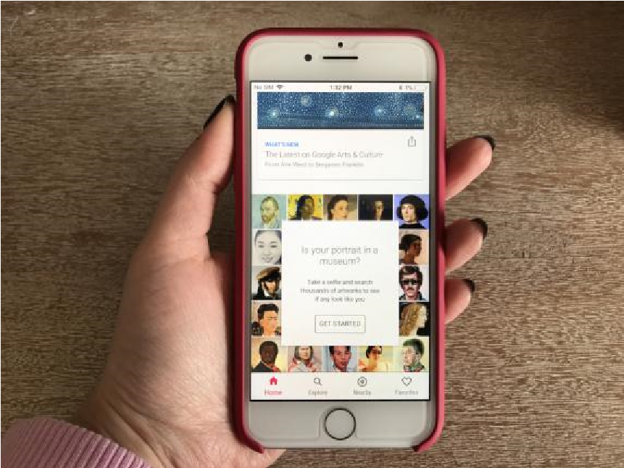

PORTALLAR

Google Arts and Culture | https://artsandculture.google.com/partner?hl=en
Google Arts & Culture | https://artsandculture.google.com/
Heritage on the Edge | https://artsandculture.google.com/project/heritage -on-the-edge
Europeana | https://www.europeana.eu/portal/en
Smithsonian Open Acess | https://www.si.edu/openaccess
ArtUK | https://artuk.org/
Mexican Ministry of Culture | https://mexicana.cultura.gob.mx/
Memorica | https://memoricamexico.gob.mx/
OpenGLAM | https://open-  collections.okfn.org/items/browse?search=&type= 18
DPLA | https://dp.la/
MIMO | https://mimo-international.com/MIMO/
Archaeological Open Acess Collections | https://www.archaeological-analytics.com/us-andcanadian-archaeology-open-access-collections
Digital Agnes | https://agnes.queensu.ca/digital-agnes/
English Heritage | https://www.english-heritage.org.uk/
Creative Commons | https://search.creativecommons.org/collections
Wikimedia Commons | https://commons.wikimedia.org/wiki/Main_Page
Wikidata | https://m.wikidata.org/wiki/Wikidata:WikiProject_s um_of_all_paintings
OpenCulture | http://www.openculture.com/
ArteTV | https://www.arte.tv/en/
TED Talks | https://www.ted.com/
Wikiart | https://www.wikiart.org/
Daily Art | https://www.getdailyart.com/

YOUTUBE KANALLARI
Google Arts & Culture | https://www.youtube.com/user/GoogleArtProject
The Art Assignment | https://www.youtube.com/user/theartassignment/vi deos
Smarthistory | https://www.youtube.com/user/smarthistoryvideos/v ideos
VernissageTV | https://www.youtube.com/user/henrichy0205yt/vide os
Getty Museum | https://www.youtube.com/user/gettymuseum/videos
Christie's | https://www.youtube.com/user/christiesauctions/vid eos
İstanbul Modern | https://www.youtube.com/channel/UCFjzHp2Qf6Q mvY1Zqrix4cg
Mekan Artı | https://www.youtube.com/channel/UCnOy2JqUTZld sak_wBbb9Rw
Zorlu Performans Sanatları Merkezi | https://www.youtube.com/channel/UC8882ICsExdx6leIfOUclg
Devlet Opera ve Balesi Arşivi | https://www.youtube.com/user/KulturTurizmBak/vid eos

EVDE SPOR VE MEDİTASYON
Cihangir Yoga | https://www.youtube.com/channel/UCuhwFG_W WUVXI2D5CtOXHLQ/videos
MacFit Official | https://www.instagram.com/macfitofficial/?hl=tr
Ücretsiz Yoga Kanalları | https://www.elitedaily.com/p/10-yoga-youtubechannels-thatll-take-your-practice-to-the-nextlevel-8681031
Meditopia – Meditasyon (Website + App) | https://meditopia.com/tr/
Evde Egzersiz Kanalları | https://www.pastemagazine.com/health/fitness/t he-10-best-fitness-youtube-channels/
Pilates Videoları | https://www.cosmopolitan.com/healthfitness/g28765236/best-pilates-youtubechannels-videos/
Yolculuk Terapisi’nin Evde Spor ve Meditasyon Önerileri | http://www.yolculukterapisi.com/evde-spor-ve-  meditasyon/

DİĞER
İlham veren TED Konuşmaları | https://oggusto.com/blog/detay/2952/basarili-isinsanlari-oneriyor-en-ilham-veren-tedkonusmalari.html
Pratik Yemek Kanalları | https://oggusto.com/blog/detay/2946/pratiktarifler-bulabileceginiz-en-iyi-youtube-yemekkanallari.html

KAYNAKÇA
- Bilgi Üniversitesi Kültür Politikaları ve Yönetimi Araştırma Merkezi: https://kpy.bilgi.edu.tr/tr/haber/tum-dijital-platformlar/1252
- Yolculuk Terapisi: http://www.yolculukterapisi.com/
- Oggusto Blog: http://oggusto.com/

